Gratitude and Praise, Spiritual Warfare 14, Father's Love
October 27, 2016

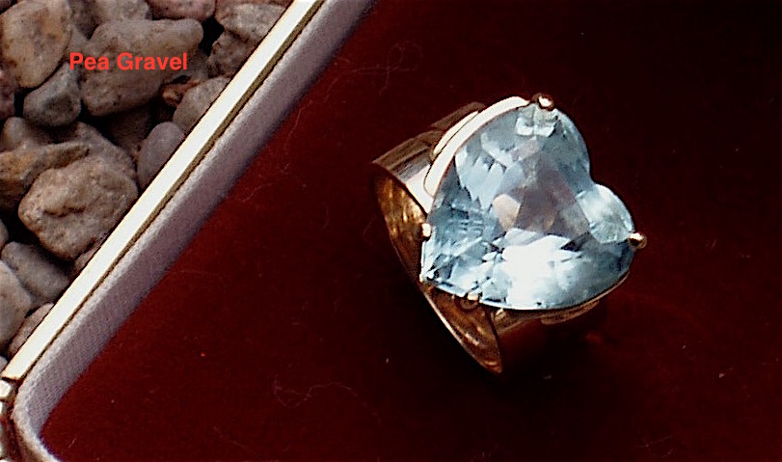
May the encouragement and love of God be with us all as we face the challenges of the day.

I’ve been feeling very disconnected lately, because of all the distractions, and I know I’ve slipped a wee bit on putting the Lord first, so I came into prayer a little apprehensive today. The Lord had appeared to me in the garden two nights ago and told me that He missed me. But my readings also talked about repentance…and I knew I had slipped, so I did repent.

Isn’t it so hard to reconnect when you know you’ve blown it? I know it is for me.

But today as I came into prayer, Abba Father didn’t waste anytime.

He began, "I am not angry or displeased with you, little Clare."

I started to feel choked up with emotion, 'cause I was so grateful.

He continued, "These hateful feelings of inadequacy, are not from Me or My Son. They are from demons, so cast them off, Beloved Daughter."

Daddy, please deliver my heart and mind from these bitter thoughts. Take them away, I pray. Please take them away. I want to have a worshipful heart.

He continued, “Yes. This is where I am taking My Body, into continual praise and worship. It is so easy for you to forget all I’ve done for you and not give thanks on a daily basis, especially when you are feeling sick.”

I asked Him, "Would you please restore me so I can work?" 'Cause I was feeling really weak and out of it. Totally out of it.

He answered, "You were right to see part of this as a suffering, because it is. But I can help you carry this in My strength. Part of this is your schedule shift, that will fade away in the next few days. But until then it is a good offering."

Oh my goodness! There is no one on Earth anywhere who has this strength and all I need is just a little drop and it will be well with me.

He continued, "You are tired. In fact, you are exhausted. You are carrying a burden. Yet a little while and it will be lifted. In the meantime, know that what you are carrying is important to Me.

"You see, there is no strength greater than praise in times of adversity. I am readying you all to carry your crosses with dignity and strength, not hauntingly, lamely, or crushingly. I need for you all to stand tall in the coming months as you carry that which I will allow.
"I want you to be beacons of My Light, Emissaries of My Son, shining in the darkness of fear, terror, and scrutiny as well as doubt. I want you to carry faith, hope, love and the brilliant light of My Crucified Son who walked in love through all His dark ordeals.
"You are the light bearers since the one who was called turned away to embrace the darkness and scorn My Dignity and Power.

"Now We have many light bearers…the seed which fell to the ground and died brought forth an ocean of light bearers. And since this is the hour of increasing darkness, your lights shall shine even more. But to keep your torch from going out, you must cultivate a habit of worship, thanksgiving and praise, every moment of the day."

Oh, dear Lord. How can I do that? I'm feeling so weak in my body.

"This is a supernatural gift I will impart to those who ask."

I am asking you, Father God, please give me a double or triple portion of the light so I can help others.

"You will have what you need, Clare. But you must be vigilant to protect and increase it, because every effort will be made by the evil ones to steal it from you. Right now you are but a flicker. I want to ignite you as His Glorious Bride. But you must believe.

"You must believe that We have overcome the darkness, that you are commissioned, that you are needed. That there will be battles, there will be casualties, but you will not be overcome. I will restore, reinvigorate, re-sparkle you in My presence.

"Practicing this praise is what will erect a strong wall of authority before you, wherever you go. Have you not heard that I inhabit the praises of My people? (Psalm 22:3) How then, can you be overcome if you are praising Me?"

Father, can You explain to me what constitutes praise?

"First off, thanks giving, a humble heart of gratitude for even the littlest blessing. And then recognizing in ever widening circles that I have provided for you and blessed you to the very core of your being. Begin always with an attitude of profound gratitude. Nothing overcomes evil like a thankful heart. There is no foothold for the enemy to enter and sow seeds of bitterness which later choke out life.

"Once you have connected with that gratitude, give voice to it. Simply thank Me. Oh, how I love to hear 'thank You' from My Children. So few return to thank Me. Most are thinking about what else they want and do not yet have. Even as Scripture has it, they “lust” after things for their own pleasure. (James 4:2)

"This is a very easy trap to get into as you well know. It begins small, just like a seed of bitterness. It is a seed of avarice and greed. It is easily justifiable because there is always something you can claim to need, yet you have more than enough.

"There is a certain false sense of security when you acquire and have things, many things. It seems as though you are more secure but in reality you are more tied down and tethered to the Earth and your passions. Distraction comes with this seed and soon it is nearly impossible to pass even a few moments without thinking about what new thing you can have.

"It is a fast growing cancer whose remedy is only in self-denial and gratitude. A heart of satisfaction with what I have provided for you. And if it becomes blatantly obvious that more is needed, I will approach you, you need not approach Me. I will speak to your heart in this way, “I would like you to have so and so.” There will be a peace accompanying it that is so very different from the lustful and burning suggestions, and distracting desire and anxiety that avarice causes.

"But as you find joy in the little things in life, even in nature, which displays itself all around you - you begin to sing a song of gratitude in your heart. This is the beginning of praise which needs to be nourished so that you may build a bulwark of honor to Me all around you.

"Then I come to inhabit your praises. Then the demons fear to come near, lest they be singed by the flames of Love that constantly burn the foolish things of the world away from the soul.

"To be caught up in My Praises is one gigantic grace that only you can cultivate after I have given the grace. It is a constant 24-7 song of the heart, whether it is heard by the ear or heard only by the spiritual ears.

"I prefer that the sound waves penetrate the space you inhabit. They shatter strongholds and greatly suppress evil. Where demons once had an easy entry, now they must struggle - only to get closer to the source of praise that is indeed electrifying and damaging them.

"So many secrets are tied into praise, Clare. So many things are crumbled down. Self-pity finds no foothold. Grumbling and detracting are a comedown in the presence of praise. Finding fault with others and demanding perfection of yourself and others - Oh, that simply doesn’t happen in the heart filled with praise and thanksgiving.

"In fact, if there is something to note about another soul, it is their virtue, which inspires you to give even more thanks. I am telling you: praise is a way of life that defeats every force and the guile of the enemy. It makes them depressed.

"Yes, something to laugh about…but I am most serious. They are depressed when they hear you praise Me. It means they are losing the battle for your mind. Ask Me for this gift My Children, and then guard your hearts and use it as a way of life."

And that was the end of His message.

What a precious privilege to hear Abba Daddy’s instruction.

And I have a very sweet story to tell about Him, as well.

As some of you know, I grew up without a father as an only child. When I became a Christian, I had a dream that I was walking with my father on the beach somewhere. We were talking and enjoying one another’s company. I remember, we walked into town where the shops were and he took me into a jewelry shop, but he didn’t buy anything. And that’s all I remembered.
Recently, before my mother passed on, she took out a jewelry box with a ring in it. A giant heart shaped aquamarine set in gold. Then she told me that my Father had bought it for me when I was born and she had kept it all these years.

It fit me perfectly…but was way too large, and I thought to wear it would be too ostentatious. My father was a well-known designer and he loved extraordinary things.

In any case, I held onto this ring all these years, waiting for the right person to give it to. But several nights ago, Father God came to me in my prayers and asked me to get this ring out. Then He told me that He was with my father when he bought it for me. That He had chosen it for me, that someday I might know how much He loved me.

It almost looks like a chunk of ice or water, it is so clear. And Daddy made me to understand that He’d seen all my tears as a child who was abandoned by her father and mother, and He wanted me to know how much He loved me the whole time I was growing up.

I was so deeply touched as He asked me to put it on my finger. And now I wear it for writing, prayer and worship - to remind me that I am loved by my Father in Heaven. That has always been the hardest thing for me to accept…as I am sure it is for most of us. The enemy works very hard to cause self-hatred.

So, I wanted to share this with you. How wonderful our Heavenly Father is, how involved He is in our lives, and that He constantly is looking for ways to tell us, “You are precious to Me. I see your tears and your fears. I love you when you fail and when you triumph. And nothing can ever change that.”

